Scenario 2: As per the CIDR create an VPC, and 2 subnets – public subnet and private subnet.
VPC - 10.10.10.0/26
- Subnet: 10.10.10.0/27
- Public Subnet: 10.10.10.32/28
Ensure that both DNS resolution is selected
Step 1: lets create an VPC.
Navigate to VPC > click on create VPC.
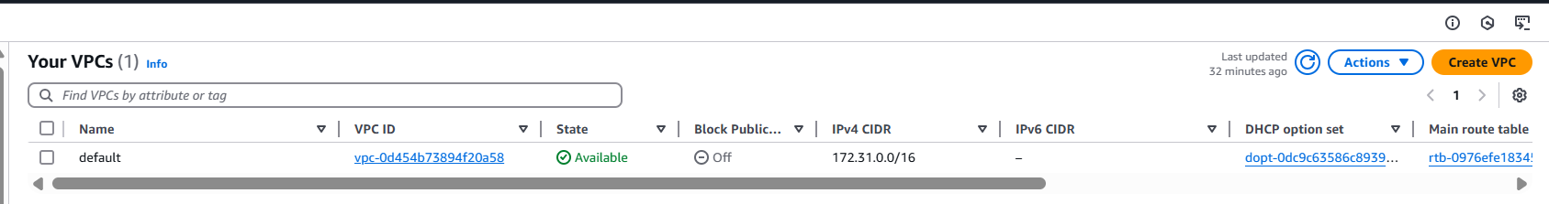
Step 2:
- Provide a name to VPC – MY-VPC
- Select IPv4 CIDR manual input and provide an CIDR– 10.10.10.0/16
- IPv6 CIDR block – No IPv6 CIDR Block
- Tenancy – Default
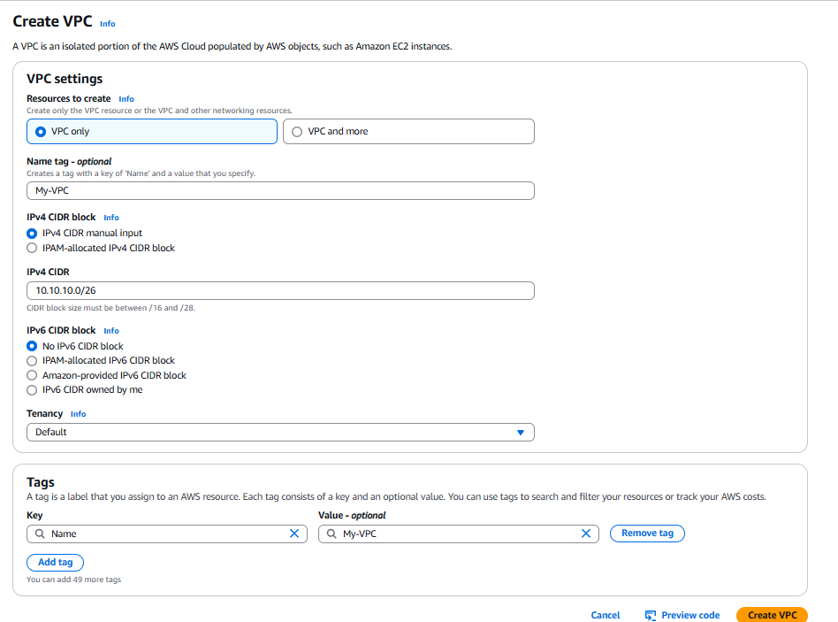
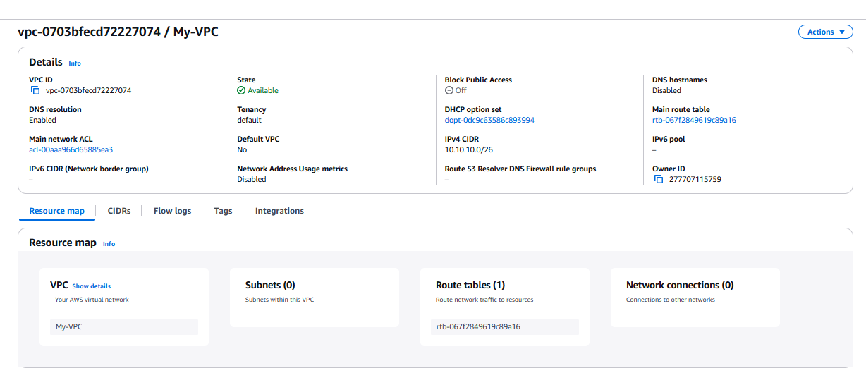
Step 3: lets Create an subnets.
Private Subnet: 10.10.10.0/27
Public Subnet: 10.10.10.32/28
Step 4: navigate to subnet > click on create
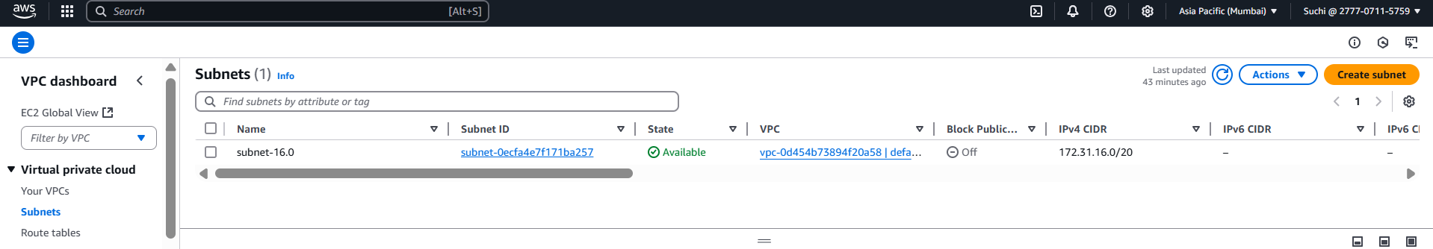
Step 5: select the VPC which we have created.
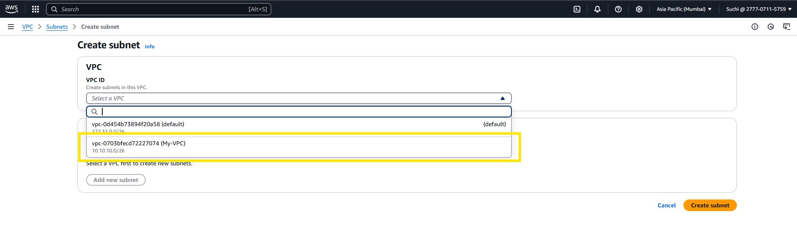
Step 6: provide the subnet name and ipv4 subnet CIDR which we have planned.
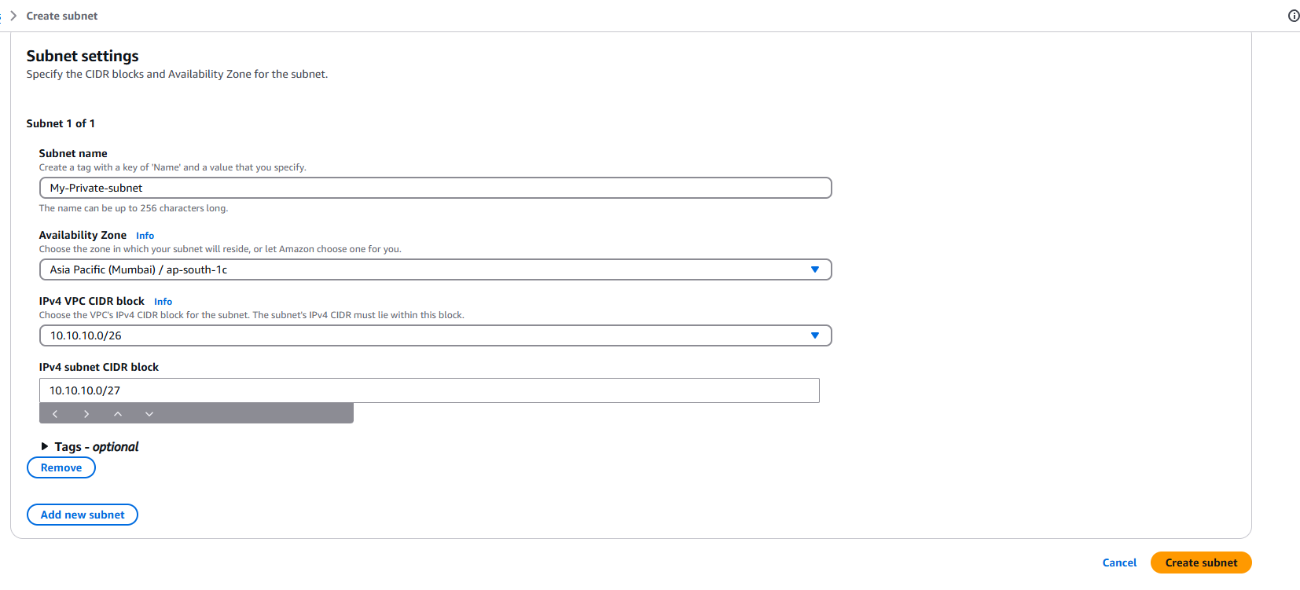
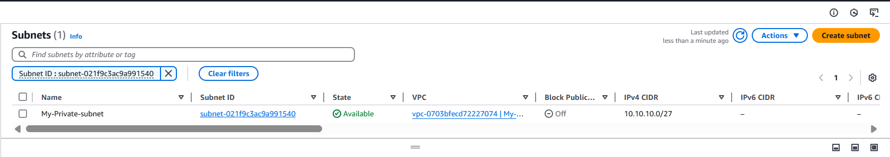

Step 7: lets create the same for public subnet.
